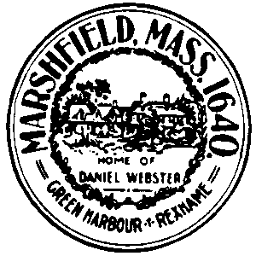
Town of Marshfield - Meeting Notice
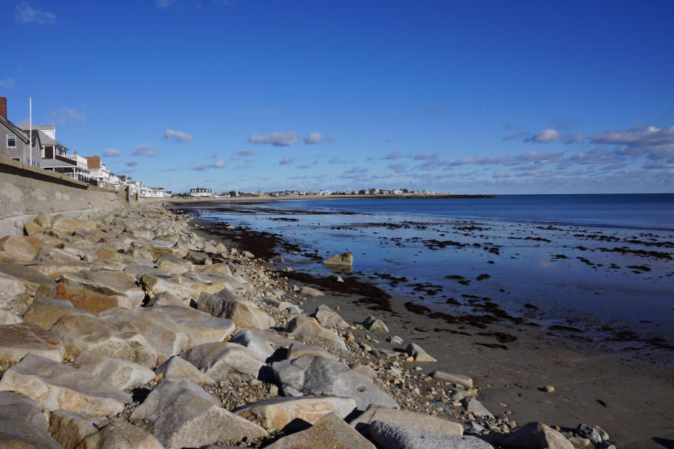
Informational Update on Feasibility Assessment
Beneficial Reuse of Sediment Dredged from Green Harbor

Presentation on the Town’s project to evaluate the feasibility of nourishing Marshfield beaches using sediment dredged from Green Harbor. Question and answer period to follow presentation.

Date: Wednesday July 25, 2018
Where: New Program Room, Veterans Memorial Library
Time: 7:00 to 8:30 PM

